**[CS 401 ARTIFICIAL INTELLIGENCE SECTION B FAST NU, LAHORE CAMPUS**

**FINAL EXAM (3 hours) May 17, 2013.**

**Max Marks: 65 I wish you all the best!**

* **Answer in the space provided. Extra sheet is allowed for rough work.**
* **Questions are not allowed.**
* **Calculator sharing is not allowed**
* **Be neat and precise and show all working clearly**

**QUESTION 1 (Marks: 10)**

Find the first, second and third principal directions for the following data and project your data onto those directions. **Show all steps in detail**.

|  |  |  |
| --- | --- | --- |
| x1 | x2 | x3 |
| 1 | 0 | 0 |
| 2 | 0 | 0 |
| -1 | 5 | 1 |
| 1 | -5 | 1 |
| 4 | 1 | 0 |
| 3 | 2 | 0 |
| 0 | 0 | 0 |
| 0 | 2 | -1 |
| 0 | -2 | -1 |
| 0 | -3 | 0 |

**QUESTION 2 (MARKS: 10)**

Design an artificial neural network that has a decision boundary as shown below. Make sure you completely specify the network along with its **weights** and the **activation function** used at each unit. Draw the network clearly and neatly and show working.

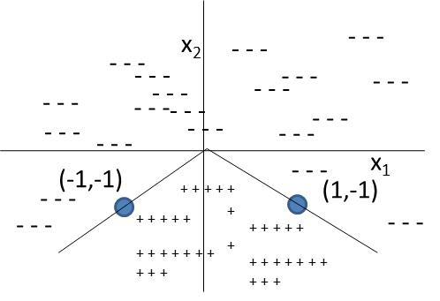

**QUESTION 3 (MARKS: 10)**

Complete the partially drawn decision tree shown below using the data table. Use information gain computed with maximum classification error. Show all working clearly.

|  |  |  |  |
| --- | --- | --- | --- |
| **A** | **B** | **C** | **Label** |
| y | 0 | 0 | +1 |
| n | 1 | 1 | +1 |
| y | 0 | 1 | +1 |
| n | 1 | 0 | +1 |
| y | 0 | 0 | +1 |
| n | 1 | 1 | +1 |
| n | 1 | 0 | +1 |
| n | 0 | 1 | -1 |
| n | 0 | 1 | -1 |
| n | 1 | 1 | -1 |

**QUESTION 4 (Marks: 5)**

Around 70% students who get a job are CS graduates. Also, around 60% students who get a job are MS holders. There are overall 80% chances of getting a job. Also, there are an overall 40% people who are CS graduates and have an MS. What is the probability of finding a job when a student has an MS and is a CS graduate? You are free to use the **Naïve Bayes’** assumption if needed. Indicate where you use this assumption.

**QUESTION 5 (MARKS: 5)**

Suppose the speed of an airplane is a function of some variable x. The relationship between the two is shown below. Make fuzzy sets to represent the input variable (x) and output variable (speed) and write down rules that would roughly govern the output when given the input variable. Note: Inference is not required.

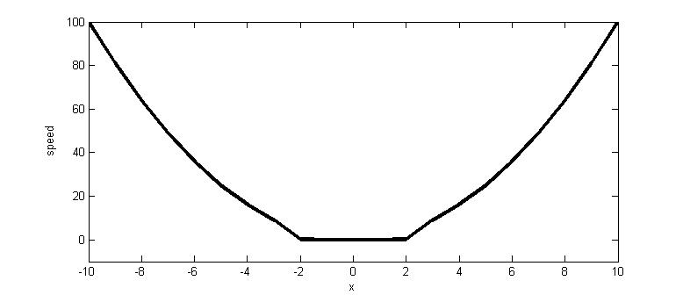

**QUESTION 6 (MARKS: 2+2+3+3)**

1. Suppose we have a probability distribution of a random variable A, which can take 4 possible values. What is the maximum entropy this variable can have and why?
2. Suppose the distance of a point from three cluster centers is 1, 2 and 3. What is the fuzzy membership of this point in the three clusters when fuzzy clustering is used and degree of membership is 2.
3. Suppose you have to navigate through the following maze. Dark lines are obstacles through which you cannot pass. The actions allowed are:horizontal up or down (2 actions), vertical up or down (2 actions) and diagonal up or down (4 actions as from (2,2) you can go to (1,3), (3,3),(1,1) or (3,1)). All horizontal actions have a cost = 0.2, all vertical actions have a cost = 0.3 and all diagonal actions have a cost equal to 0.4. Design a **good admissible heuristic** to solve this problem. What is your heuristic and why?



1. If you were to apply breadth first search then what is the space and time complexity in terms of the total number of rows and columns?

**QUESTION 7 (5+5+5)**

1. Show how uniform cost search proceeds when graph search is applied to the following. The table shows the heuristic distance to the **goal node K**. **Start node is A**. The graph edges show the actual distance from one node to the other. What is the final path and what is the path length?



1. If you were to apply genetic algorithm for finding the shortest route from A to K then how would you represent the problem and the fitness function? Give one example of each.
2. If you were to apply genetic algorithm for finding the shortest route from A to K then how would you define cross over and mutation operators? Give one example of each.